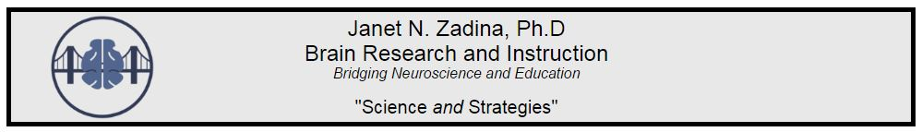

Pathway to Wellness: Reframing to Reset

- What am I afraid of?

- How realistic is that fear?

- What steps have I or can I take?

- One good thing that came (or may come) from this bad event:

- A lesson I have learned from this is:

